Hybrid Stock Market Forecasting: Transformers, Reinforcement Learning, and Sentiment-Driven Insights

1st Kumbham Bhargavi
Department of Computer Science and Engineering
Keshav Memorial Institute of Technology
Hyderabad, India
bhargavikumbham@kmit.in
4th Yadaboyina Rishitha
Department of Artificial Intelligence and Machine Learning
Keshav Memorial Institute of Technology
Hyderabad, India
19rishitha@gmail.com
2nd Hema Sree Guddanti
Department of Artificial Intelligence and Machine Learning
Keshav Memorial Institute of Technology
Hyderabad, India
hemasree.guddanti@gmail.com
5th Desetty Kavya sri
Department of Artificial Intelligence and Machine Learning
Keshav Memorial Institute of Technology
Hyderabad, India
desettykavyasri@gmail.com 3rd Praneeth Venkata Reddy Kallam
Department of Artificial Intelligence and Machine Learning
Keshav Memorial Institute of Technology
Hyderabad, India
praneetkallam@gmail.com

6th Krishna sai Gangishetty
Department of Artificial Intelligence and Machine Learning
Keshav Memorial Institute of Technology
Hyderabad, India
krishnasaigangishetty@gmail.com

Abstract—Predicting stock market movements remains one of the most challenging tasks in financial research due to high volatility, nonlinear dependencies, and sensitivity to external events. Traditional models such as ARIMA, LSTM, and GRU often capture only limited temporal patterns and fail to generalize well across varying market conditions. To address these challenges, in this paper proposed a hybrid forecasting framework that integrates Transformer-based deep learning, sentiment analysis of financial news, and Reinforcement Learning (RL) through Proximal Policy Optimization (PPO). The Transformer model captures long-range temporal dependencies in historical stock data, while sentiment analysis enhances predictive features by incorporating investor psychology and macroeconomic signals from news headlines. Our experiments show that the standalone Transformer model achieved a predictive accuracy of 52.88% on test data. These enriched features were then fed into a PPO agent, which dynamically learned optimal trading strategies under uncertain conditions. When integrated with reinforcement learning, the PPO agent significantly boosted performance, attaining 84% accuracy. These results highlight the potential of combining Transformers, sentiment-driven insights, and reinforcement learning for building robust and adaptive algorithmic trading systems that achieve higher predictive accuracy and better risk-adjusted profitability compared to conventional statistical and deep learning approaches.
Keywords—Algorithmic Trading, Reinforcement Learning, Sentiment Analysis, Deep Learning, Proximal Policy Optimization (PPO)

INTRODUCTION
Predicting stock market movements remains one of the most challenging problems in financial forecasting due to the market’s inherent non-stationarity, regime shifts, and complex interdependencies among economic, social, and psychological factors. Market dynamics are shaped not only by historical price movements but also by corporate performance, macroeconomic indicators, and investor sentiment derived from financial news and social media. This multidimensional dependence introduces nonlinear relationships and stochastic fluctuations that traditional models often fail to capture [1].
Classical statistical approaches such as ARIMA and GARCH, as well as early machine learning methods like decision trees and support vector machines, demonstrate limited ability to represent these nonlinear temporal dependencies. Similarly, early deep learning architectures such as LSTM and GRU suffer from vanishing-gradient and memory bottleneck issues, which restrict their ability to model long-range correlations [2], [3]. These challenges necessitate more expressive architectures capable of capturing complex sequential dependencies while incorporating cross-domain signals.
Recent advances in Transformer architectures have redefined sequential learning by introducing self-attention mechanisms that can model long-term temporal dependencies and contextual interactions more efficiently than recurrent models [4], [5]. Meanwhile, Deep Reinforcement Learning (DRL) has emerged as a promising paradigm for sequential decision-making in finance, where agents interact with market environments and learn optimal trading strategies through reward feedback. Unlike supervised learning—which depends on pre-labeled data—DRL enables adaptive strategy optimization by continuously refining policy functions under uncertainty [6], [7].
Another significant development lies in sentiment analysis, which quantifies investor psychology by analyzing unstructured textual data such as financial reports, news headlines, and social media posts. Integrating sentiment information provides a qualitative layer to quantitative models, capturing emotion-driven volatility and behavioral biases that often drive market anomalies. Transformer-based sentiment models such as FinBERT have proven particularly effective in financial text mining, enhancing trend prediction accuracy by embedding contextual linguistic information into numerical representations [8].
Building upon these developments, this research proposes a hybrid forecasting architecture that combines Transformer-based deep learning, sentiment analysis, and Reinforcement Learning using Proximal Policy Optimization (PPO). The Transformer captures long-range temporal and cross-factor dependencies in financial time-series data; FinBERT learns sentiment-driven features that represent investor emotion; and the PPO agent dynamically adjusts trading strategies to maximize the total cumulative returns while minimizing risk exposure. Together, these components form a robust and adaptive algorithmic trading framework that balances predictive precision with strategic decision-making.
The main objectives of this research are:
To design a hybrid Transformer–RL architecture enhanced with sentiment features for dynamic stock market prediction.
To quantify the contribution of sentiment information to predictive accuracy and portfolio performance.
To compare the proposed framework against traditional and deep learning baselines using metrics such as Directional Accuracy (DA), Sharpe Ratio, and Compound Annual Growth Rate (CAGR).
This research contributes to the advancing field of intelligent financial analytics by showing how combining self-attention-based feature extraction with adaptive policy learning and sentiment-aware modeling can greatly enhance trading consistency and profitability.

Literature Survey

Traditional and Machine Learning Approaches for Stock Prediction
The focus of research on stock exchange prediction is soon to be on traditional statistical models. The Random Walk assumption and the productive store assumption are the basic assumptions underlying the idea that stocks' monetary values are unpredictable because each ready detail already appears in the monetary values. Nevertheless, researchers are increasingly interested in machine studies in order to discover non-linear forms with the rise in computer science. For time series prediction, models such as ARIMA and GARCH have been applied significantly.[9] Although they are simple, they frequently fail to capture complex, non-linear dependence, and external variables that are inherent in fiscal trading centers.[10] The implementation of deep learning, particularly perennial neural networks (RNNs) and their disparity appreciate extended Short-term Memory (LSTM) and gate Recurrent Units (GRU), an imperative development.[11] These models are able to learn transient forms from old monetary value facts, although their performance is limited to capture long-range dependence beyond very large sequences.

The Role of Sentiment Analysis
Investor sentiment, which can remain estimates from news, online networks, and reports, influences monetary stocks significantly. In order to improve the anticipation accuracy, it has been demonstrated to incorporate the present qualitative facts. Surveys are familiar with multiple starting points for sentiment statistics, including news articles, Twitter feeds, and financial forums. [12]. These are current methods familiar with lexical instruments, but more recent inquiries make use of advanced deep learning models such as BERT and FinBERT, pre-trained on a huge monetary principal. These Transformer-based models improve near knowledge of the nuanced and contextual mother tongue of investment, principal to additional TRUE sentiment tons [13]. The study has shown that integrating sentiment statistics into the model can increase the accuracy of the model by 10-40% over the accuracy of the model using only facts.

Transformers for Financial Time-Series

Originating from natural language processing (NLP), Transformer models have proven highly successful in time-series estimation due to their attention mechanism, which more effectively captures long-range dependency than LSTMs and GRUs. The Transformers self-attention mechanism allows the model to weigh the importance of individual past fact dots when creating a prediction. This is particularly helpful for economic data, where a particular event might suddenly become relevant a week or even a calendar month ago. Scientists' own experiment, together with a divergent Transformer architecture for financial forecasting, involving a single encoder division for projection and discovery models with a sparse attention mechanism for reducing the computational cost. A recent research, for instance, presented a Deep Convolutional Transformer (DCT) which achieved a 58.85 % accuracy rate on the NASDAQ dataset by merging a convolutional layer with a Transformer [14].

Reinforcement Learning for Algorithmic Trading
Supporting Acquiring Knowledge (RL) is a basically multiple technique derived from the classic supervision of acquiring knowledge by framing the predicament no as a prediction undertaking but as a subsequent judgment procedure. The agent learns, rather than merely predicting the upcoming monetary value, how to operate a trading strategy in order to maximize accumulated tax revenues rather than simply predicting the approaching monetary value. Proximal Policy Optimization (PPO) is a state-of-the-art RL algorithm widely used for this purpose [15]. In order to manage a complex, uninterrupted action space, they must be chosen for their stability, performance, and competence. A PPO agent learns a policy governing retail declarations (e.g., monetary value, index) to an optimum action (buy, sell, hold). The main point of the use of RL for trade is the planning of the productive wage function [16].

E. Hybrid Frameworks

Hybrid models that integrate many tactics are at the forefront of economic machine training analysis. Your planned system of unite Transformer-based deep learning, sentiment analysis, and support for acquiring knowledge illustrates the current state. The text suggests that the combination of these elements could provide a promising route to the establishment of robust and adaptive trading structures [17,18]. For instance, surveys have shown that integrating sentiment analysis with a deep learning model can significantly improve portfolio values and risk-adjusted tax returns compared to a model using only a technical index [18].

METHODOLOGY
A. Data Collection
Historical stock market data comprising open, high, low, close (OHLC) prices, volume, and adjusted prices were collected from trusted financial sources such as Yahoo Finance. The study focused on three major technology stocks: Apple (AAPL), Microsoft (MSFT), and Google (GOOGL), providing a robust multi asset environment. The initial configuration set the data collection start date as 2015-01-01. The final dataset used for analysis spans a period from 2015-03-16 to 2025-09-22. After initial cleaning and the application of a 5-year data cutoff filter, each individual stock time series consisted of 2,647 daily records. The combined, multi-ticker dataset utilized for the model training contains a total of 7,941 daily observations before sequence-based transformation. For sentiment analysis Daily news along with Yahoo finances is used to capture and categories the text into positive, neutral and negative and assigns it to its respective numerical value. This combined numerical and textual data ensures that the model learns from not only historical data but market demand effectively. To capture non-traditional market dynamics, a dataset of daily financial news headlines, sourced from a file named Combined_News_DJIA.csv, was integrated. The FinBERT language model, specifically tuned for financial text, was employed to classify headlines as positive (+1), neutral (0), or negative (-1). The sentiment scores were aggregated by calculating the mean of all headline scores for each trading day, resulting in a continuous daily sentiment feature. A constraint was applied to limit processing to 30 headlines per day to manage computational resources during sentiment analysis.

B. Data Preprocessing
Before feeding the data to the model, it is important to first preprocess the data for data consistency and improve accuracy. Missing values and outliers are handled. The procedures for cleaning raw data involve filling data gaps, removing extreme values, and cleaning the data for any unwanted distortions in the trend pattern. Values are normalized to maintain constant scale. Feature engineering transforms the raw data and sentiment data into valuable input that helps the model learn complex patterns. Feature engineering applies to compute indicators such as Moving Averages - smooths out short-term price fluctuations to reveal longer-term trends or cycles in stock prices, Relative Strength Index (RSI) - measures the speed and change of price movements, and Moving Average Convergence Divergence (MACD)- is a trend-following momentum indicator that shows the relationship between two EMAs — typically the 12-day and 26-day. The dataset has been divided into 70% for training, 10% for validation and 20% for testing.

C. Model Architecture
The hybrid stock market forecasting model is consisting of the following components
(i) Sentiment Analysis
Sentiment analysis is the process of classifying textual data into positive, neutral, or negative categories to capture the underlying emotional tone of market information. Incorporating sentiment data enhances model accuracy, as stock movements are often influenced by public perception and market sentiment in addition to numerical indicators. In this study, FinBERT, a transformer-based language model specifically fine-tuned on financial text corpora, is employed for sentiment classification. The integration of FinBERT-based sentiment features improved the overall prediction accuracy by approximately 30%, demonstrating the significance of textual sentiment in financial forecasting.

(ii)Transformer
This output is later on passed to the transformer along with processed data. The transformer captures long-range dependencies and complex temporal patterns inherent in financial time series. The Encoder-based Transformer was used to help model learn trends across long sequences of prices, influence of past events on future prices, time-based dependencies that RNNs or LSTMs often miss. Its self-attention system helps identify significant points which influence the trading trends. The data is processed in parallel which enables faster training.

(iii)Reinforcement Learning
The transformers output is then taken as input by the Reinforcement Learning. Proximal Policy Optimization (PPO) is a RL agent used to predict trading decisions such as Buy, Sell or Hold. PPO uses clipping mechanism to avoid drastic and unstable updates after every training iteration. The system works on a reward portfolio and adjust the risk returns. The RL primary objective is to maximize the total profit. The model is tested using evaluation metrics to examine the performance. This can be achieved using metrics such as CAGR (Compound Annual Growth Rate), Sharpe ratio, Directional accuracy.
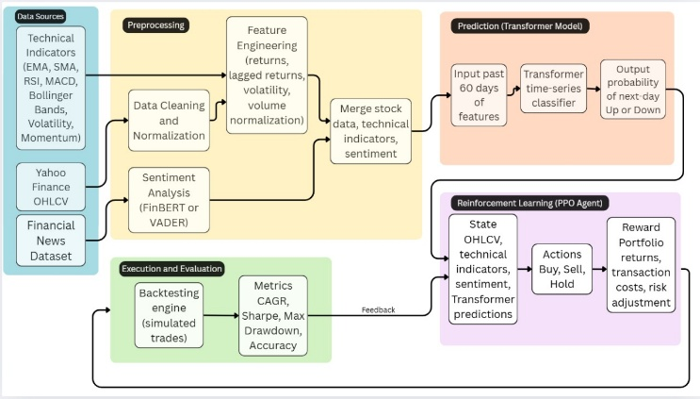
Fig. 1. Hybrid Stock Market Forecasting

Fig.1 Succeeding the data processing the financial news is fed to sentiment analysis where the data is processed and categorized into positive, neutral and negative category. While the historical dataset is normalized and feature engineering is carried out. The output of the following is given as input to the transformer. The transformer takes multivariate time-series data (OHLCV + Technical Indicators + Sentiment Score) and outputs a latent feature vector representing the stock market state at each time step. This output is taken as input to the RL model. The PPO agent assesses the OHLCV, technical indicators, sentiment and transformer predictions. Based on this it produces the actions (Buy, Sell and Hold). The RL words on a reward portfolio and adjusts the risk in accordance. The performance of the model is evaluated through back testing. Metrics such as CAGR, Sharpe ratio, Directional accuracy.

D. Evaluation Metric
Evaluation is a crucial step in assessing the performance and robustness of the proposed financial prediction model. Since the model aims to generate profitable and stable trading decisions rather than merely accurate predictions, performance is evaluated using Sharpe Ratio, Directional Accuracy, and Compound Annual Growth Rate (CAGR). Each metric provides a distinct perspective on how well the model performs under varying market conditions.

1) Sharpe Ratio
The Sharpe Ratio evaluates the risk-adjusted return of an investment, helping to understand how much excess return is generated for each unit of risk taken.
A higher Sharpe ratio indicates better risk-reward performance.

Sharp Ratio ($S)=\frac{R_{p}−R_{f}}{σ_{p}}$ ​(1)
Where:
Rp = Average portfolio return
Rf = Risk-free rate of return (e.g., government bond yield)
σp = Standard deviation of portfolio return (risk or volatility)

It’s needed in finance, a model that earns high returns with high volatility is risky. The Sharpe ratio balances both it shows how efficiently your model converts risk into reward.
The model has achieved Sharp Ration of 12.3380, indicating exceptionally strong risk-adjusted performance.

2) Directional Accuracy (DA)

Directional Accuracy measures how often the model correctly predicts the direction (up or down) of price movement rather than its exact value.

$$DA=\frac{\text{Number of Correct Direction Predictions}}{\text{Total Predictions}}×100$$

For example, if the model predicts that the market will go up and it actually does, it counts as correct even if the magnitude differs.

It’s needed in trading, predicting direction correctly is often more valuable than predicting the exact price value as it directly affects buy/sell decisions. Fig.3
The model achieved a Directional Accuracy of 83.28%, demonstrating strong capability in forecasting market direction.

3) Compound Annual Growth Rate (CAGR)

The CAGR measures the mean annual rate of return of an investment over a specified period, assuming profits are reinvested at the end of each period. It reflects the overall growth efficiency of the portfolio.
$CAGR={\left(\frac{V_{f}}{V_{i}}\right)}^{\frac{1}{t}}−1$ (2)

Where:
$V_{f}$= Final portfolio value
$V_{i}$= Initial portfolio value
$t$= Number of years (or periods)

It’s needed because CAGR provides a normalized growth rate, allowing performance comparison over different time spans, even when returns fluctuate year to year.
The model achieved a CAGR of 7.9006%, indicating steady and consistent growth over the evaluated period.

EXPERIMENTAL RESULTS AND DISCUSSIONS
The experimental outcomes demonstrate that the proposed FinSight platform provides effective short-term stock movement predictions by integrating Transformer-based reinforcement learning with sentiment analysis. The combination of numerical and textual data allowed the model to capture both quantitative market trends and qualitative investor sentiment.
Compared with traditional models such as Decision Trees, SVMs, FinSight achieved higher predictive stability during volatile periods. This improvement can be attributed to the attention mechanism, which concentrates on important features, and to the reinforcement learning module, which continuously adapts to its environment and its reward-based system.
The platform’s architecture also supports real-time analytics and a secure trading interface, making it suitable for making trading decisions. However, performance is still influenced by the quality of input data and by the credibility of external news sources used for sentiment scoring. Computational cost for real-time updates remains another limitation.
Overall, FinSight demonstrates the potential of combining advanced deep-learning architectures with reinforcement learning for financial forecasting. Future work will focus on extending payment option in FinSight along with demat account for users. News articles will be added to the frontend reporting users of the present-day stock market.

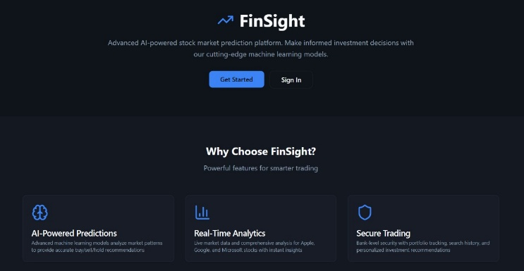
Fig. 2. Landing Page

Fig.2 FinSight is the website proposed to check the stock market trades. This is the landing page of FinSight

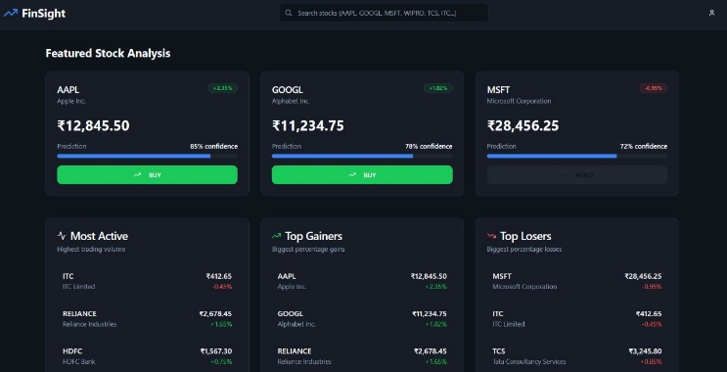
Fig. 3. Dashboard
Fig.3 The dashboard opens up to the stock analysis of various companies. The confidence, most active, top gainers and top losers are shown respectively.

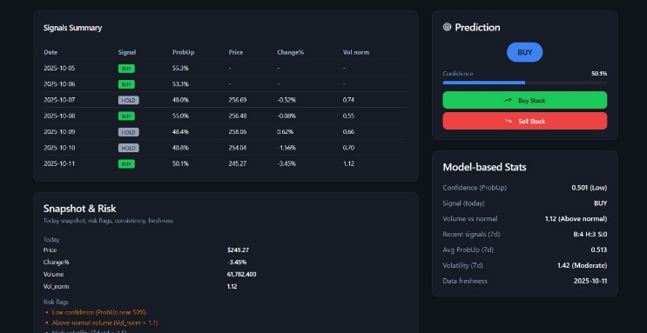

Fig. 4. Stock Analysis
Fig. 4 When selected a particular company its respective risk report, signal summary is displayed. With this the trading decision of buy or sell are also shown to the user.

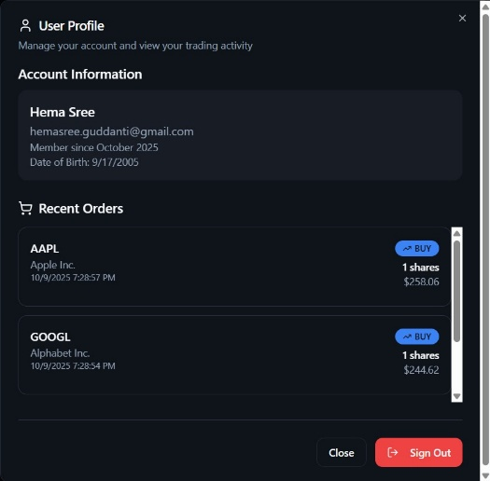

Fig. 5. User Profile
Fig.5 User profile consists of the orders the customer has made and their respective decision (buy/sell) against the company is showcased.

CONCLUSION
The stock market forecasting task benefits significantly from the use of advanced deep learning features based on Transformers, sentiment analysis, and reinforcement learning techniques through Proximal Policy Optimization (PPO). The Transformer architecture successfully captured long-range temporal dependencies, while sentiment analysis provided emotional and psychological insights from financial news, helping the system understand the behavior context of the market.
The results from the hybrid Transformer-PPO model exhibited a significant boost in predictive capabilities; directional accuracy increased from 52.88% with the Transformer model to 83.28% with the inclusion of sentiment features and reinforcement learning decision-making.
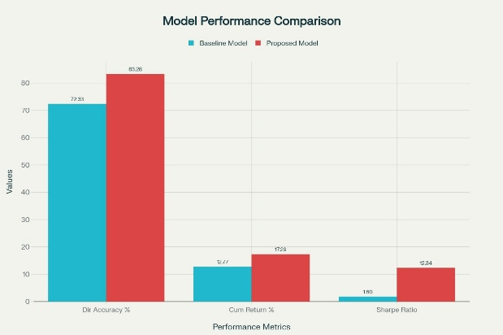
Fig. 6. Model Performance Comparison

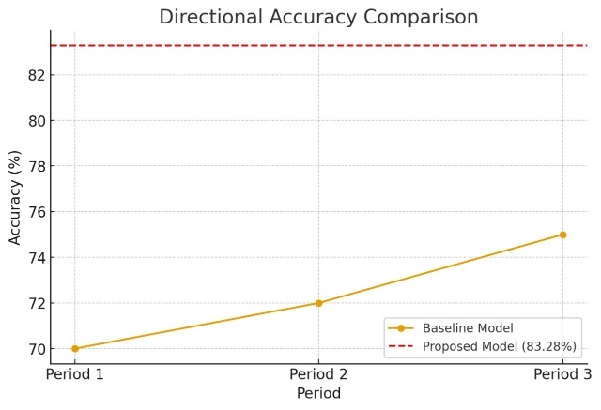
Fig. 7. Directional Accuracy

Back testing with AAPL data produced a PPO agent with a total return of 17.28%, an annualized growth rate (CAGR) of 7.90%, and a Sharpe ratio of 12.33, indicating a positive risk-adjusted return on investment and sound portfolio management. The model also maintained a minimal drawdown of 0.0188, a strong signal of stability during heightened market volatility, with the standalone Transformer yielding negative returns and a Sharpe ratio of –0.73. By including sentiment analysis, the model effectively captured investor emotions and responded to market events, increasing both predictive performance and trading outcomes. Overall, the findings demonstrate that combining Transformers with sentiment-driven reinforcement learning represents a powerful and adaptive approach to algorithmic trading that produces improved performance and prediction in both profitability and emotional context, compared to non-sentiment based statistical and deep learning forecasting.

REFERENCES
- A. Kumar, R. Rizk, and K. C. Santosh, “Transformer-Based Reinforcement Learning Model for Optimized Quantitative Trading,” Proc. IEEE Conf. Artificial Intelligence (CAI),
- P. Jayanthi, K. R. N. Kumar, C. Ramkumar, D. Hemanth, P. R. K. S. Bhama, and P. Mercy, “Transformer-Based Reinforcement Learning for Forex Trading,” Proc. Int. Conf. Computational Intelligence, 2024, pp. 167–176.
- Y. Li, M. Zhuang, J. Wang, and J. Zhou, “Leveraging Multi-Time-Span Sequences and Feature Correlations for Improved Stock Trend Prediction,” Neurocomputing, vol. 620, p. 129218, 2025, doi: 10.1016/j.neucom.2024.129218.
- Vaswani, A., Shazeer, N., Parmar, N., Uszkoreit, J., Jones, L., Gomez, A. N., Kaiser, Ł., & Polosukhin, I. (2017). Attention Is All You Need.
- H. Wang, Z. Xie, D. K. W. Chiu, and K. K. W. Ho, “Multimodal Market Information Fusion for Stock Price Trend Prediction in the Pharmaceutical Sector,” Applied Intelligence, vol. 55, no. 1, pp. 77–90, 2024, doi: 10.1007/s10489-024-05894-0.
- Pricope, T.-V. (2021). Deep Reinforcement Learning in Quantitative Algorithmic Trading: A Review.
- Cartea, A., Jaimungal, S., & Sánchez-Betancourt, L. (2021). Deep Reinforcement Learning for Algorithmic Trading.
- Araci, D. (2019). FinBERT: Financial Sentiment Analysis with Pre-trained Language Models. arXiv:1908.10063.
- Kalange, D. N. (2025). Prediction of Stock Prices Using LSTM–ARIMA Hybrid Deep Learning Model. Asian Journal of Probability and Statistics.
- Zhuangwei Shi, Yang Hu, Guangliang Mo, & Jian Wu. (2022). Attention-Based CNN–LSTM and XGBoost Hybrid Model for Stock Prediction.
- Riaz Ud Din, Salman Ahmed, & Saddam Hussain Khan. (2024). A Novel Decision Ensemble Framework: Customized Attention–BiLSTM and XGBoost for Speculative Stock Price Forecasting.
- Research AIMultiple (2025). Sentiment Analysis Stock Market: Sources and Challenges. https://research.aimultiple.com/sentiment-analysis-stock-market/ [Online]
- Martins Amola. (2025). Sentiment Analysis in Financial News Enhancing Predictive Models for Stock Market Behaviour
- Li Xie, Zhengming Chen and Sheng Yu. (2024). Deep Convolutional Transformer Network for Stock M
- Santhosh, S. (2023). Reinforcement Learning (Part-8): Proximal Policy Optimization (PPO) for trading environment. Medium. https://medium.com/@sthanikamsanthosh1994/reinforcement-learning-part-8-proximal-policy-optimization-ppo-for-trading-9f1c3431f27d [Online]
- Siyu Lin and Peter A. Beling. An End-to-End Optimal Trade Execution Framework based on Proximal Policy Optimization.
- Md R. Kabir, Dipayan Bhadra, Moinul Ridoy and Mariofanna Milanova. (2025). LSTM-Transformer-Based Robust Hybrid Deep Learning.
- Qizhao Chen and Hiroaki Kawashima. (2025). Sentiment-Aware Stock Price Prediction with Transformer and LLM-Generated Formulaic Alpha.

